Micro Project Report

Project Group ID: MPRJ_CPP_SY_A_13

Project Title: University Admission System

Student Name(s): 1.Akash Mahadev Mali (2039)

With Roll Number 2. Aditya Pramod Kore(2045)

3. Prasad Avinash Kadam (2051)

Supervisor Name: Dr. Amol Dange

Institution Name: Annasaheb Dange College of Engineering and Technology, Ashta.

Submission Date: 08 November 2025

Table of Contents
- Abstract

- Introduction

- Literature Review

- Objectives

- Methodology

- Implementation Details

- Results

- Conclusion

- Future Work

- References

Abstract

The University Admission Management System is a C++ console-based application designed to automate and simplify the entire admission process of a university. This project helps manage student information, track application status, handle fee details, and maintain admission records efficiently and accurately. It aims to replace manual record-keeping with a reliable, error-free, and time-saving computerized system.
The system is built using Object-Oriented Programming (OOP) concepts such as encapsulation, abstraction, and modularity, ensuring better organization and reusability of code. It uses file handling techniques to permanently store student and fee records in external text files, allowing all information to be retained even after the program is closed. This ensures data consistency and smooth retrieval of past records during subsequent runs.
The menu-driven interface of the program makes it easy for users to navigate through different operations such as adding new applicants, viewing admission lists, updating student details, checking payment status, and generating reports. This design ensures that even non-technical users can operate the system without difficulty.
Through this project, the efficiency of the admission process is greatly improved — reducing paperwork, eliminating human errors, and providing fast and accurate results. The system demonstrates how core C++ programming principles can be effectively applied to solve real-world problems in the education domain.
Overall, the University Admission Management System not only serves as a practical software solution but also as a learning model that integrates programming logic, data management, and structured system design into one cohesive application.

Introduction
In many educational institutions, handling student admissions manually often leads to problems such as data repetition, human errors, and difficulty in maintaining accurate records. With the growing use of technology, computerized systems have become essential for ensuring accuracy, efficiency, and better record management.
The University Admission System project has been developed to serve as an all-in-one solution for these challenges. The system allows university staff to manage student applications, verify details, handle fee payments, and update admission status — all within a single integrated program. Users can add new applicants, view or search student records, update admission details, and check fee-related information easily through a menu-driven interface.
By using C++, the project demonstrates the use of:
• Classes and Objects to represent entities such as students and their admission records.
• File Handling for saving and retrieving data from files, ensuring data persistence.
• Encapsulation and Abstraction to maintain clarity, modularity, and security in the code.
• Conditional Logic and Loops for managing user interactions efficiently.
The simplicity and structure of this project make it an excellent example of how programming fundamentals can be used to build a practical and reliable system. It provides a clear demonstration of how C++ can be applied to solve real-world administrative problems in an educational setting.

Literature Review
The University Admission System project is developed based on several academic and practical references that combine both theoretical understanding and real-world application. These sources guided the program’s design, logic, and coding approach, ensuring a balance between simplicity, efficiency, and scalability.
- “Object-Oriented Programming with C++” by E. Balagurusamy
This book served as the foundation for applying Object-Oriented Programming (OOP) principles such as encapsulation, inheritance, and data abstraction in C++. These concepts were directly used in designing the Applicant and University classes, ensuring clear data organization and code modularity. The book’s coverage of constructors, destructors, and dynamic memory management helped implement efficient handling of student records without memory leaks.
- “The C++ Programming Language” by Bjarne Stroustrup
As the definitive guide by the creator of C++, this book provided a deep understanding of advanced features such as file handling, exception management, and class hierarchies. These concepts guided the implementation of reliable file operations to store and retrieve admission data. The discussions on stream classes (ifstream, ofstream, fstream) helped build a stable system for reading and writing applicant details, ensuring persistence even after program termination.
- “Let Us C++” by Yashavant Kanetkar
Kanetkar’s practical approach helped in structuring the menu-driven interface of the program. The book’s clear examples on loops, conditional statements, and user input validation influenced the overall control flow design of the admission system.

- Online Tutorials and Learning Resources
Modern development practices are increasingly supported by online learning platforms. Resources such as GeeksforGeeks, TutorialsPoint, and W3Schools were referenced for clarifying syntax and understanding file handling operations (ifstream, ofstream, ios::app, ios::trunc). YouTube channels like CodeWithHarry and Abdul Bari’s C++ Course offered practical demonstrations of Object-Oriented Programming and data file management, which directly influenced the implementation of record creation, updating, and retrieval in the admission system. These sources helped refine both the logic structure and error-handling mechanisms in the project.
- Research Papers on University Admission Systems (Conceptual Background)
Recent research and academic papers on computerized admission and student management systems highlight the importance of digital transformation in educational administration.
From these studies, the following insights were integrated into the project’s design and functionality:
• Automation minimizes human intervention, ensuring faster and error-free admission processing.
• Persistent storage of applicant data enables easy retrieval, analysis, and report generation.
• Scalable and modular architecture allows the system to expand in the future.
for example, by integrating online application portals or database connectivity.

Objectives
1. To Develop a User-Friendly Interface
• The system is designed with a simple, menu-driven command-line interface that allows users to easily navigate through all major functions such as adding new students, viewing applications, checking admission status, and managing fee records.
• The interface ensures that even users with limited technical knowledge can operate the system smoothly, minimizing data entry errors and improving overall efficiency.
2. To Implement Efficient Student Record Management
• The project maintains a structured record of all applicants, including details such as name, age, course applied for, contact information, and admission status.
• This module ensures that student data can be quickly accessed, searched, or updated, allowing staff to save time and maintain accuracy throughout the admission process.
3. To Enable Secure Fee Management and Status Tracking
• Each student record includes complete details of total fees, amount paid, and pending balance, along with the payment status.
• The system validates inputs to prevent incorrect or duplicate entries, ensuring that all financial transactions remain accurate and transparent.
4. To Ensure Reliable Data Storage Using File Handling
• The program uses file input/output operations to store student and fee details permanently in text files, maintaining all information even after the program is closed.
• This guarantees data persistence and continuity, enabling the system to restore and manage previously saved records upon restart.
- To Implement an Accurate Fee Calculation and Update System
• The system automatically calculates the pending or total fee amount based on the student’s course, fee structure, and payment details entered by the user.
• This reduces manual calculations and ensures transparency, accuracy, and consistency in financial management during the admission process.

- To Enable Editing, Searching, and Deletion Functionalities
• Users can edit or update existing student records, modify admission details, or correct entered information without removing the entire record.
• The system also provides options to delete applications or search for specific students quickly, making it easier to manage and organize data efficiently.
- To Incorporate Data Validation and Error Handling
• The program includes various input checks to prevent invalid entries such as incorrect email formats, missing fields, or unrealistic fee amounts.
• These validations improve the reliability of the system by reducing runtime errors and maintaining the overall accuracy and consistency of stored information.

Methodology
1. Developing a User-Friendly Interface module.
To make the system easy to operate, a menu-driven command-line interface was implemented using standard C++ I/O streams (iostream). The interface allows users to navigate through major functionalities like adding student records, checking admission status, viewing fee details, and managing applications.
A do-while loop was used to continuously display the main menu until the user decides to exit. Each menu option calls the respective member function from the Applicant or AdmissionSystem class, ensuring modular execution. This structure prevents confusion and allows even users with minimal computer skills to operate the system effectively without encountering input or navigation errors.

2. Efficient Student Record Management Module
Student information management is at the core of the system. Each applicant’s details — including name, age, course, contact information, and admission status — are stored and processed through well-structured class objects.
This is achieved by defining a class (e.g., Applicant) that encapsulates all relevant student attributes and methods to handle their data.
Operations such as adding, viewing, editing, and deleting records are managed through functions that read and write student data to text files.
This modular structure allows for quick data retrieval and updates without affecting the integrity of other records. It also ensures that large volumes of student data can be processed efficiently during peak admission periods.

3. Secure Fee Management and Status Tracking Module
The fee management functionality ensures that every applicant’s financial information — including total course fee, amount paid, pending balance, and payment status — is stored securely and updated dynamically.
Data validation is performed whenever payment details are entered to prevent incorrect or duplicate records. This minimizes inconsistencies such as overpayments or negative balances.
By separating fee-related logic into independent functions, the system maintains clarity and ensures financial accuracy across all student records.

4. Reliable Data Storage Using File Handling Module
The program employs C++ file handling through the <fstream> library to achieve persistent data storage.
Student and fee details are written into external text files (e.g., students.txt, fees.txt) using ofstream for output and read back using ifstream during system startup.
This ensures that all records remain available even after the application is closed or restarted. The use of file modes like ios::app (for appending data) and ios::trunc (for rewriting updated files) guarantees data consistency and prevents duplication.
Thus, the system ensures continuity of operations and minimizes manual record-keeping.

5. Implementing Accurate Fee Calculation and Update System Module
The system automatically computes the total, paid, and pending fees for each applicant based on their course selection and payment entries.
This is achieved through simple arithmetic logic embedded within the fee management module, ensuring precise and transparent calculation.
Whenever a payment is made, the system updates the corresponding student record and recalculates the balance instantly.
This feature eliminates manual financial errors and ensures consistency between stored data and user input, making the admission process more efficient for both staff and applicants.

6. Editing, Searching, and Deletion Functionalities Module
The application supports full data manipulation capabilities, including record editing, searching, and deletion.
Users can modify existing entries such as student name, course, contact number, or payment status without overwriting the entire file.
The search function allows users to retrieve specific student records based on key fields like name, course, or application date, making data handling faster and more precise.
Additionally, the deletion feature enables safe removal of outdated or duplicate entries, maintaining database cleanliness and organization.

7. Data Validation and Error Handling Module
Robust input validation and error handling mechanisms are integrated throughout the code to maintain data integrity.
Checks are implemented to prevent issues such as:
- Invalid or missing data (e.g., blank names, invalid email format)
- Negative or unrealistic fee entries
- Age or eligibility inconsistencies
These measures prevent runtime errors and protect against logical inconsistencies in stored records.
In addition, exceptions and boundary conditions are carefully handled during file reading and writing operations to prevent data corruption or crashes.

6. Implementation Details

1.File Mapping Header Code
#include <iostream> // For standard input and output operations
#include <fstream> // For handling file operations (read/write)
#include <vector> // For storing lists of applicants or records
#include <string> // For handling text data like names, emails, and courses
#include <iomanip> // For formatted output in reports and tables
#include <limits> // For input validation (clearing input buffer)
using namespace std;

2. Class-wise Description
// Class representing an applicant applying for admission
class Applicant {
private:
// Applicant details
string name, age, email, course, status, date;
double totalFees, amountPaid, pendingFees;
string feeStatus;

// ---------- Validation Functions ----------

// Validate name: must contain only alphabets and spaces
bool checkName(string s) {
if (s.empty()) return false;
for (char c : s)
if (!isalpha(c) && c != ' ') return false;
return true;
}

// Validate age: must be numeric and between 17–100
bool checkAge(string s) {
if (s.empty()) return false;
for (char c : s)
if (!isdigit(c)) return false;
int ageNum = stoi(s);
return (ageNum >= 17 && ageNum <= 100);
}

// Validate email: must contain '@' and '.'
bool checkEmail(string s) {
int at = s.find('@');
int dot = s.find('.', at + 1);
return (at > 0 && dot > at + 1 && dot < s.length() - 1);
}

// Validate course name: only alphabets and spaces allowed
bool checkCourse(string s) {
if (s.empty()) return false;
for (char c : s)
if (!isalpha(c) && c != ' ') return false;
return true;
}

// Validate date format (DD-MM-YYYY)
bool checkDate(string d) {
if (d.length() != 10 || d[2] != '-' || d[5] != '-') return false;
string dd = d.substr(0, 2), mm = d.substr(3, 2), yyyy = d.substr(6, 4);
for (char c : dd + mm + yyyy)
if (!isdigit(c)) return false;

int day = stoi(dd), month = stoi(mm), year = stoi(yyyy);
if (year < 2000 || year > 2100 || month < 1 || month > 12) return false;

int daysInMonth[12] = {31,28,31,30,31,30,31,31,30,31,30,31};
if ((year % 4 == 0 && year % 100 != 0) || year % 400 == 0) daysInMonth[1] = 29;

return (day >= 1 && day <= daysInMonth[month - 1]);
}

// Validate amount input (must be numeric and can have one decimal)
bool checkAmount(string s) {
if (s.empty()) return false;
int dots = 0;
for (char c : s) {
if (c == '.') dots++;
else if (!isdigit(c)) return false;
if (dots > 1) return false;
}
return true;
}

// Update pending fees and fee status
void updateFees() {
pendingFees = totalFees - amountPaid;
if (pendingFees <= 0) {
pendingFees = 0;
feeStatus = "Fully Paid";
} else if (amountPaid == 0) {
feeStatus = "Unpaid";
} else {
feeStatus = "Partially Paid";
}
}

public:
// Default constructor
Applicant() {
totalFees = amountPaid = pendingFees = 0;
status = "Pending";
feeStatus = "Unpaid";
}

// Display applicant details neatly
void display() {
cout << "Name: " << name << endl
<< "Age: " << age << endl
<< "Email: " << email << endl
<< "Course: " << course << endl
<< "Status: " << status << endl
<< "Admission Date: " << date << endl
<< "Total Fees: " << fixed << setprecision(2) << totalFees << endl
<< "Fees Paid: " << amountPaid << endl
<< "Pending Fees: " << pendingFees << endl
<< "Fee Status: " << feeStatus << endl;
}

// Apply for admission — collects and validates all input data
void apply(vector<Applicant> &apps) {
Applicant a;

// Name validation
while (true) {
cout << "Enter name: ";
getline(cin, a.name);
if (checkName(a.name)) break;
cout << "Invalid name. Use only letters and spaces.\n";
}

// Age validation
while (true) {
cout << "Enter age: ";
getline(cin, a.age);
if (checkAge(a.age)) break;
cout << "Invalid age. Enter between 17-100.\n";
}

// Email validation
while (true) {
cout << "Enter email: ";
getline(cin, a.email);
if (checkEmail(a.email)) break;
cout << "Invalid email format.\n";
}

// Course validation
while (true) {
cout << "Enter course: ";
getline(cin, a.course);
if (checkCourse(a.course)) break;
cout << "Invalid course name.\n";
}

// Date validation
while (true) {
cout << "Enter date (DD-MM-YYYY): ";
getline(cin, a.date);
if (checkDate(a.date)) break;
cout << "Invalid date format.\n";
}

// Fees entry
while (true) {
cout << "Enter total fees: ";
string s;
getline(cin, s);
if (checkAmount(s)) {
a.totalFees = stod(s);
break;
}
cout << "Invalid amount.\n";
}

// Amount paid
while (true) {
cout << "Enter amount paid: ";
string s;
getline(cin, s);
if (checkAmount(s)) {
a.amountPaid = stod(s);
if (a.amountPaid <= a.totalFees) break;
cout << "Amount exceeds total fees.\n";
} else {
cout << "Invalid amount.\n";
}
}

// Finalize fees and save to file
a.updateFees();
apps.push_back(a);
ofstream fout("applicants.txt", ios::app);
fout << a.name << endl << a.age << endl << a.email << endl
<< a.course << endl << a.status << endl << a.date << endl
<< a.totalFees << endl << a.amountPaid << endl
<< a.pendingFees << endl << a.feeStatus << endl;
fout.close();
cout << "Application submitted successfully.\n";
}

// View admission status using email
void viewStatus(vector<Applicant> &apps) {
string mail;
cout << "Enter your email: ";
getline(cin, mail);
bool found = false;
for (auto &a : apps) {
if (a.email == mail) {
a.display();
found = true;
break;
}
}
if (!found) cout << "No record found.\n";
}

// Pay remaining fees
void payFees(vector<Applicant> &apps) {
string mail;
cout << "Enter your email: ";
getline(cin, mail);
bool found = false;

for (auto &a : apps) {
if (a.email == mail) {
found = true;
if (a.pendingFees == 0) {
cout << "All fees already paid.\n";
break;
}

string s;
double amt;
cout << "Pending fees: " << a.pendingFees << endl;

while (true) {
cout << "Enter amount to pay: ";
getline(cin, s);
if (checkAmount(s)) {
amt = stod(s);
if (amt > 0 && amt <= a.pendingFees) break;
cout << "Invalid amount range.\n";
} else cout << "Invalid amount format.\n";
}

a.amountPaid += amt;
a.updateFees();

// Update the file with new fee details
ofstream fout("applicants.txt", ios::trunc);
for (auto &x : apps)
fout << x.name << endl << x.age << endl << x.email << endl
<< x.course << endl << x.status << endl << x.date << endl
<< x.totalFees << endl << x.amountPaid << endl
<< x.pendingFees << endl << x.feeStatus << endl;
fout.close();

cout << "Payment successful.\n";
break;
}
}

if (!found) cout << "Email not found.\n";
}

// Cancel an application
void cancel(vector<Applicant> &apps) {
string mail;
cout << "Enter your email: ";
getline(cin, mail);
bool found = false;

for (int i = 0; i < apps.size(); i++) {
if (apps[i].email == mail) {
found = true;
char c;
cout << "Cancel application? (y/n): ";
cin >> c;
cin.ignore();

if (c == 'y' || c == 'Y') {
apps.erase(apps.begin() + i);
ofstream fout("applicants.txt", ios::trunc);
for (auto &x : apps)
fout << x.name << endl << x.age << endl << x.email << endl
<< x.course << endl << x.status << endl << x.date << endl
<< x.totalFees << endl << x.amountPaid << endl
<< x.pendingFees << endl << x.feeStatus << endl;
fout.close();
cout << "Application cancelled.\n";
} else {
cout << "Cancellation aborted.\n";
}
break;
}
}

if (!found) cout << "Email not found.\n";
}

// Admin review and collection report
void adminReview(vector<Applicant> &apps) {
if (apps.empty()) {
cout << "No applications found.\n";
return;
}
cout << "\nA - Approve/Reject applications\nC - View collection report\nEnter choice: ";
char option;
cin >> option;
cin.ignore();
if (option == 'A' || option == 'a') {
// Review and update pending applications
vector<int> pendingIndexes;
for (int i = 0; i < apps.size(); i++)
if (apps[i].status == "Pending") pendingIndexes.push_back(i);

if (pendingIndexes.empty()) {
cout << "No pending applications.\n";
return;
}

cout << "\n----------------------------------------------------------------------------------------\n";
cout << left << setw(4) << "No" << setw(22) << "Name"
<< setw(32) << "Email" << setw(16) << "Course"
<< setw(12) << "Status" << setw(16) << "Date"
<< right << setw(16) << "Fee Paid" << endl;
cout << "----------------------------------------------------------------------------------------\n";

for (int idx = 0; idx < pendingIndexes.size(); idx++) {
int i = pendingIndexes[idx];
cout << left << setw(4) << (idx + 1)
<< setw(22) << apps[i].name
<< setw(32) << apps[i].email
<< setw(16) << apps[i].course
<< setw(12) << apps[i].status
<< setw(16) << apps[i].date
<< right << setw(14) << fixed << setprecision(2)
<< apps[i].amountPaid << endl;
}

cout << "----------------------------------------------------------------------------------------\n";

int sel;
while (true) {
cout << "Enter applicant number to review (0 to cancel): ";
if (!(cin >> sel)) {
cin.clear();
cin.ignore(numeric_limits<streamsize>::max(), '\n');
cout << "Invalid input.\n";
continue;
}
cin.ignore();
if (sel == 0) return;
if (sel < 1 || sel > pendingIndexes.size()) {
cout << "Invalid applicant number.\n";
continue;
}
break;
}

int realIndex = pendingIndexes[sel - 1];
apps[realIndex].display();

int choice;
while (true) {
cout << "\n1. Accept\n2. Reject\nEnter choice: ";
if (!(cin >> choice)) {
cin.clear();
cin.ignore(numeric_limits<streamsize>::max(), '\n');
cout << "Invalid input.\n";
continue;
}
cin.ignore();
if (choice == 1) {
apps[realIndex].status = "Accepted";
break;
} else if (choice == 2) {
apps[realIndex].status = "Rejected";
break;
} else cout << "Invalid choice.\n";
}

// Save updated application status
ofstream fout("applicants.txt", ios::trunc);
for (auto &x : apps)
fout << x.name << endl << x.age << endl << x.email << endl
<< x.course << endl << x.status << endl << x.date << endl
<< x.totalFees << endl << x.amountPaid << endl
<< x.pendingFees << endl << x.feeStatus << endl;
fout.close();
cout << "Status updated successfully.\n";
}

// Fee collection report generation
else if (option == 'C' || option == 'c') {
string fromDate, toDate;
cout << "Enter start date (DD-MM-YYYY): ";
getline(cin, fromDate);
cout << "Enter end date (DD-MM-YYYY): ";
getline(cin, toDate);

// Convert DD-MM-YYYY to integer (YYYYMMDD) for easy comparison
auto dateToInt = [](string d) -> int {
if (d.length() != 10) return 0;
return stoi(d.substr(6, 4) + d.substr(3, 2) + d.substr(0, 2));
};

int start = dateToInt(fromDate), end = dateToInt(toDate);
if (start == 0 || end == 0 || start > end) {
cout << "Invalid date range.\n";
return;
}

double rangeCollected = 0, rangeTotal = 0;
vector<Applicant> rangeApps;

// Filter applicants within date range
for (auto &a : apps) {
int appDate = dateToInt(a.date);
if (appDate >= start && appDate <= end) {
rangeCollected += a.amountPaid;
rangeTotal += a.totalFees;
rangeApps.push_back(a);
}
}

// Display report
cout << fixed << setprecision(2);
cout << "\n------------------------ Fee Collection Report ------------------------\n";
cout << "From: " << fromDate << " To: " << toDate << endl;
cout << "-----------------------------------------------------------------------\n";
cout << left << setw(20) << "Name" << setw(15) << "Course"
<< setw(15) << "Date" << right << setw(12) << "Total"
<< setw(15) << "Paid" << setw(15) << "Pending"
<< setw(15) << "Status" << endl;
cout << "-----------------------------------------------------------------------\n";

if (rangeApps.empty()) cout << "No payments in this date range.\n";
else {
for (auto &a : rangeApps) {
cout << left << setw(20) << a.name
<< setw(15) << a.course
<< setw(15) << a.date
<< right << setw(12) << a.totalFees
<< setw(15) << a.amountPaid
<< setw(15) << a.pendingFees
<< setw(15) << a.feeStatus << endl;
}
}
cout << "-----------------------------------------------------------------------\n";
cout << "Total fees assigned: Rs. " << rangeTotal << endl;
cout << "Total fees collected: Rs. " << rangeCollected << endl;
cout << "-----------------------------------------------------------------------\n";
} else {
cout << "Invalid option.\n";
}
}

// Load applicant data from file when program starts
void load(vector<Applicant> &apps) {
ifstream fin("applicants.txt");
if (!fin) return;
while (true) {
Applicant a;
if (!getline(fin, a.name)) break;
getline(fin, a.age);
getline(fin, a.email);
getline(fin, a.course);
getline(fin, a.status);
getline(fin, a.date);
string s1, s2, s3, s4;
getline(fin, s1);
getline(fin, s2);
getline(fin, s3);
getline(fin, s4);
if (s1.empty()) continue;
try {
a.totalFees = stod(s1);
a.amountPaid = stod(s2);
a.pendingFees = stod(s3);
} catch (...) { continue; }
a.feeStatus = s4;
apps.push_back(a);
}
fin.close();
}
};

3.Main Function
// -------------------- Main Program --------------------
int main() {
vector<Applicant> apps;
Applicant app;
app.load(apps); // Load previous data
int ch;
do {
cout << "\n\n---------- UNIVERSITY ADMISSION SYSTEM ---------------\n";
cout << "1. Apply\n2. View Status\n3. Admin Review\n4. Cancel Application\n5. Pay Fees\n6. Exit\nEnter choice: ";
cin >> ch;
cin.ignore();
switch (ch) {
case 1: app.apply(apps); break;
case 2: app.viewStatus(apps); break;
case 3: {
string pass;
cout << "Enter admin password: ";
getline(cin, pass);
if (pass == "admin@1234") app.adminReview(apps);
else cout << "Access denied.\n";
break;
}
case 4: app.cancel(apps); break;
case 5: app.payFees(apps); break;
case 6: cout << "Exiting...\n"; break;
default: cout << "Invalid choice.\n";
}
} while (ch != 6);
return 0;
}
7. Results
• Terminal Results
Student Applications:
The students apply for the the course, enter their details like name, age, email, date of admission, and pay the fees.
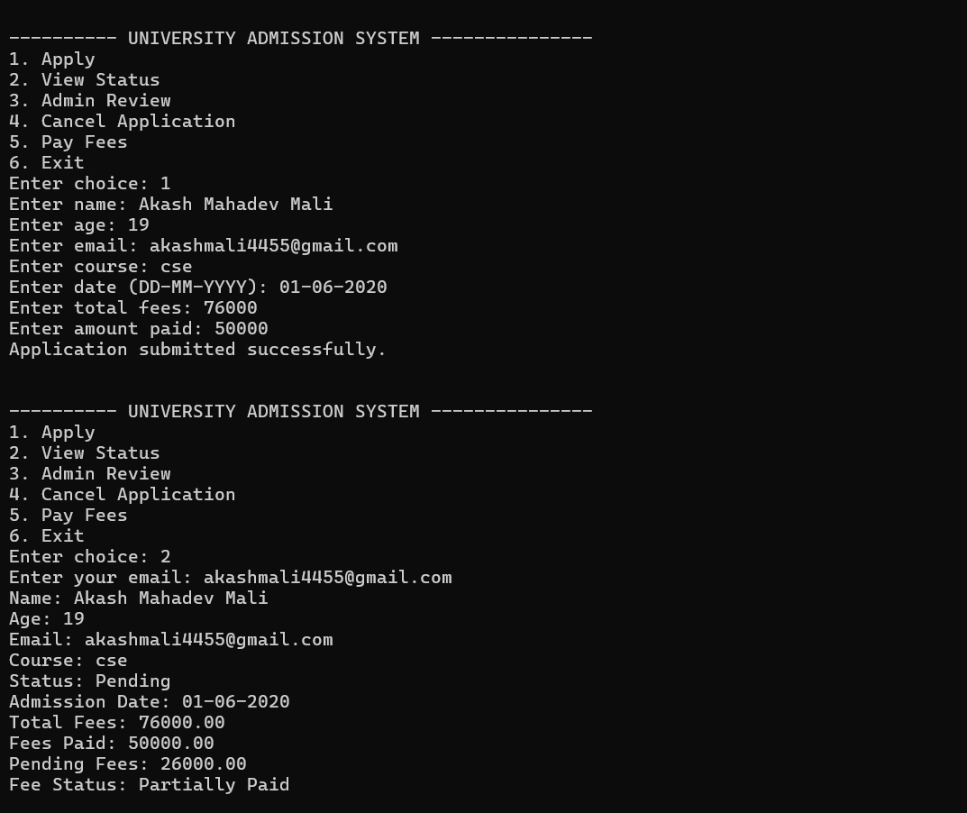

Student Applications:
The students apply for the the course, enter their details like name, age, email, date of admission, and pay the fees.
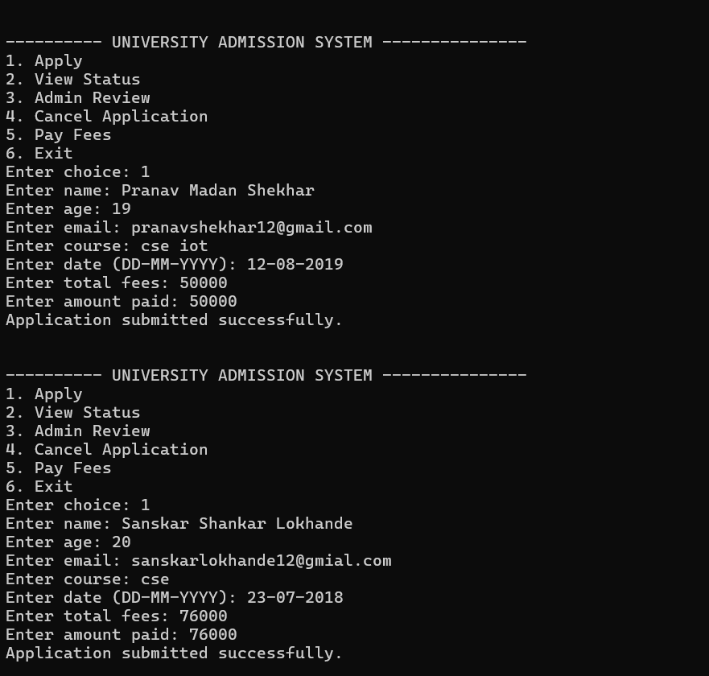

Student Applications:
The students apply for the the course, enter their details like name, age, email, date of admission, and pay the fees.
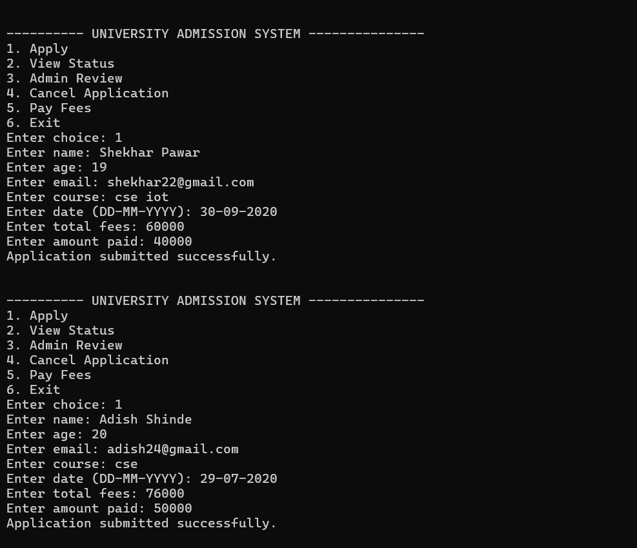

Student Applications:
The students apply for the the course, enter their details like name, age, email, date of admission, and pay the fees.
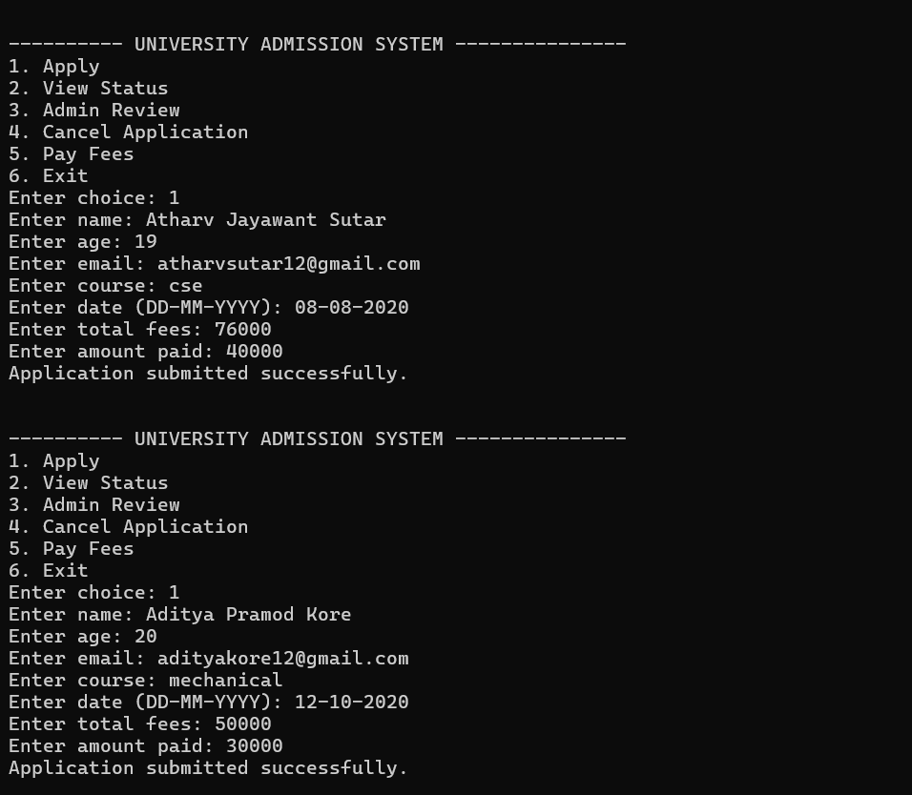

Admin Review:
The admin reviews the application and select whose application to accept and whose to reject. The admin can also check for the fees collection details in a specific date range as well as the total fees that was assigned and got collected.
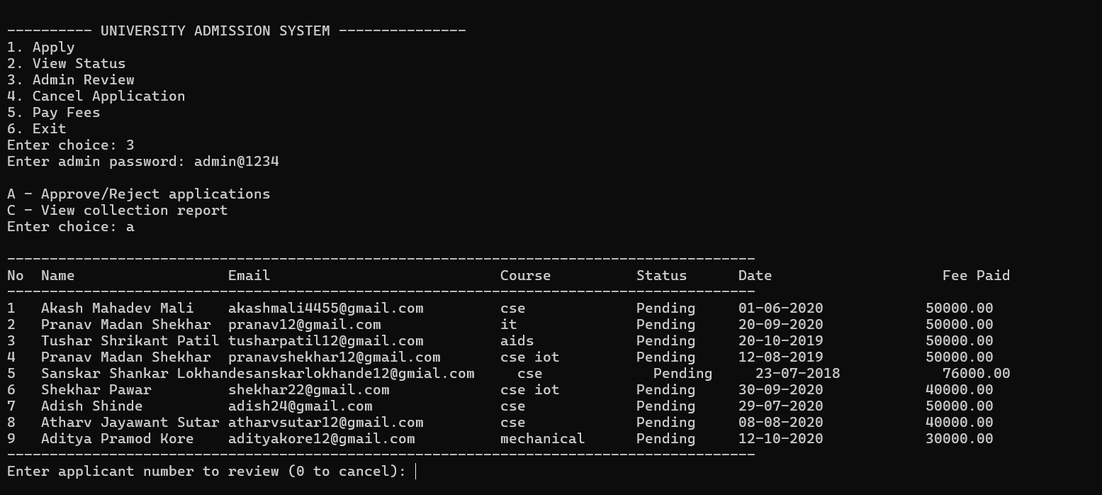

The admin Selects the number of the applicant of whose the review is to be done and then selects whether the application is to be accepted or rejected.
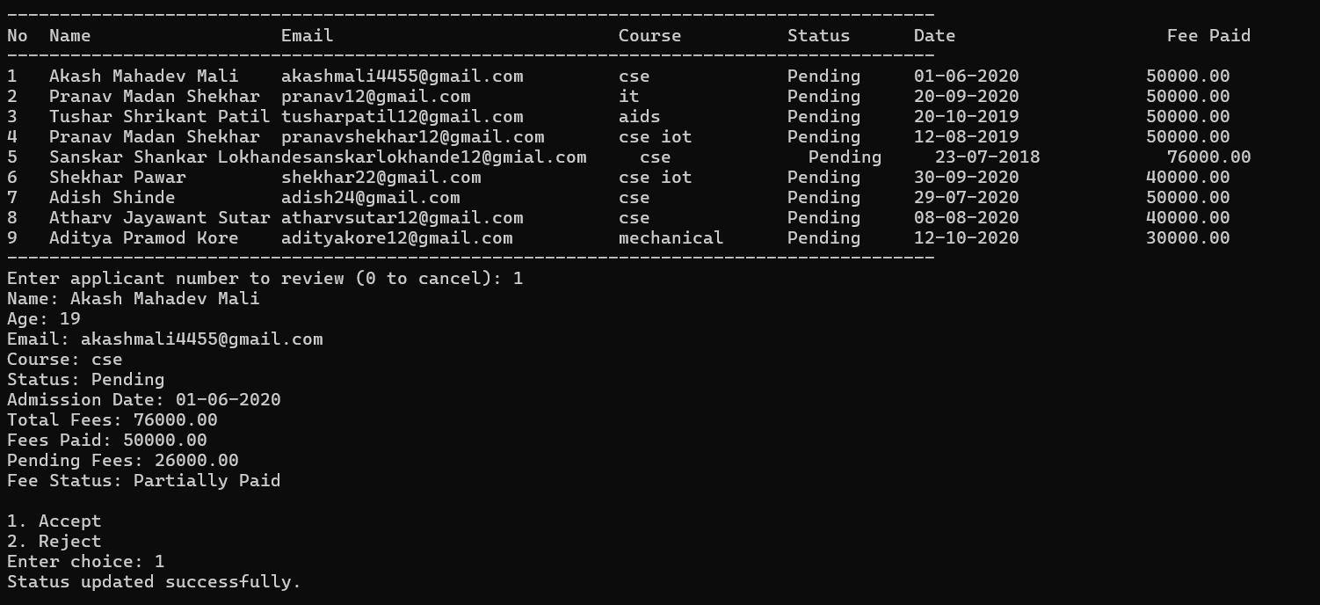

The admin Selects the number of the applicant of whose the review is to be done and then selects whether the application is to be accepted or rejected.
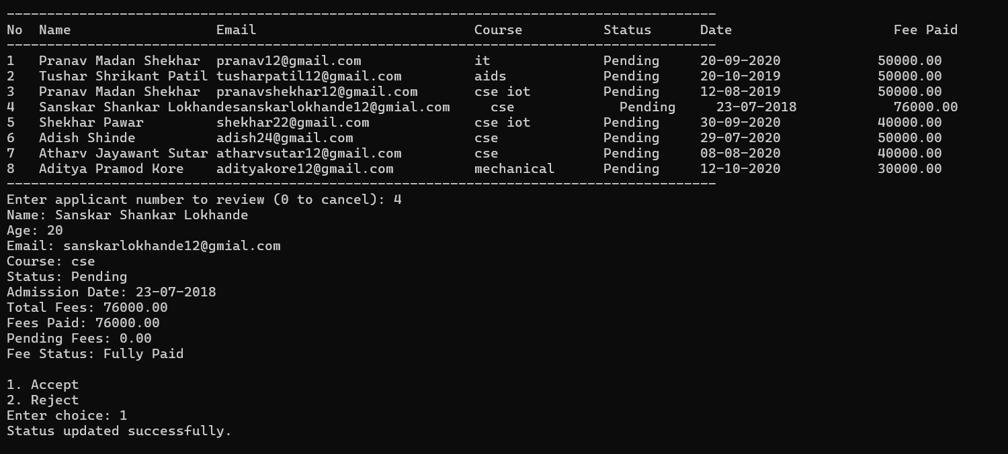

The admin Selects the number of the applicant of whose the review is to be done and then selects whether the application is to be accepted or rejected.
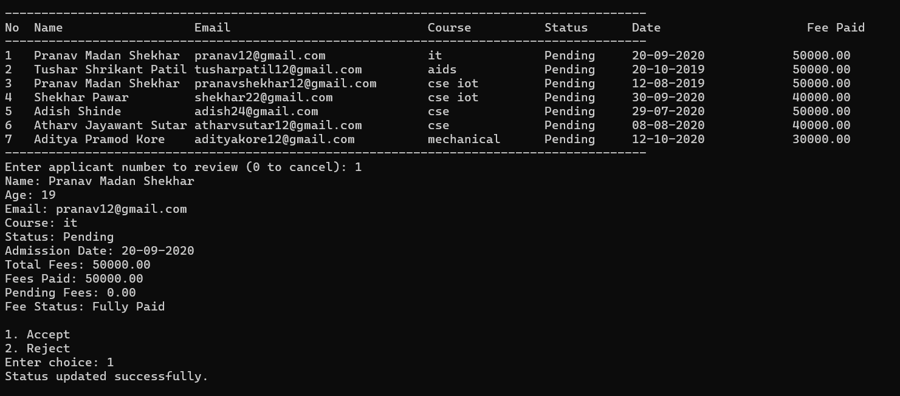

The admin selects the option c and checks for the fees collection in the particular date range.
And also which candidate has completed all the dues as well as how many candidates have the pending fees.
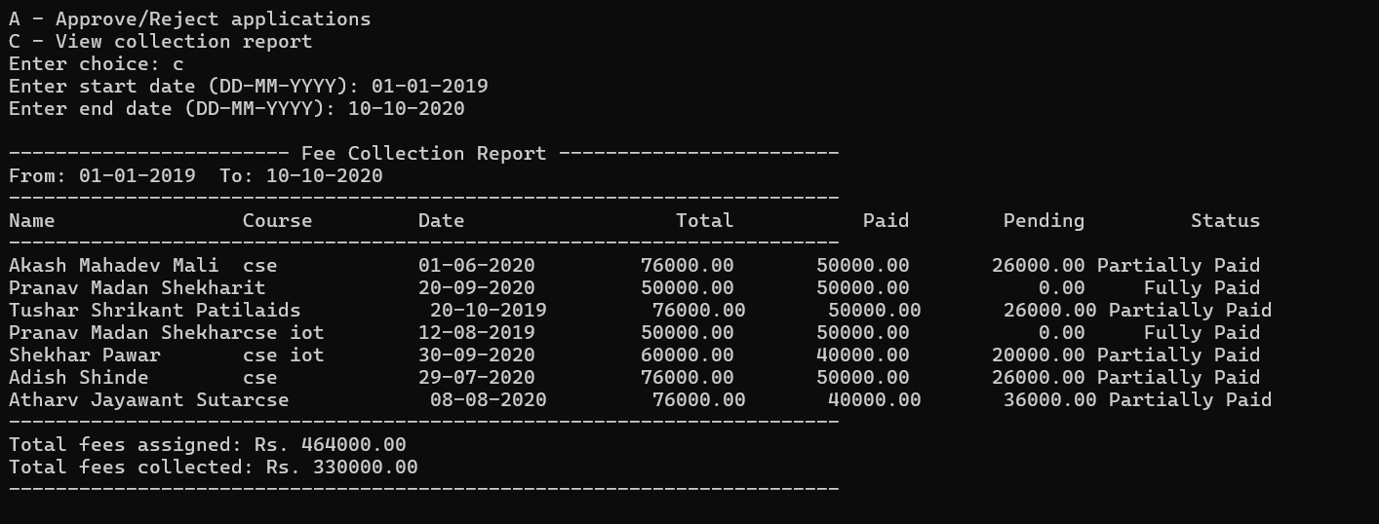

View status:
The applicants review whether their applications have been accepted or not.
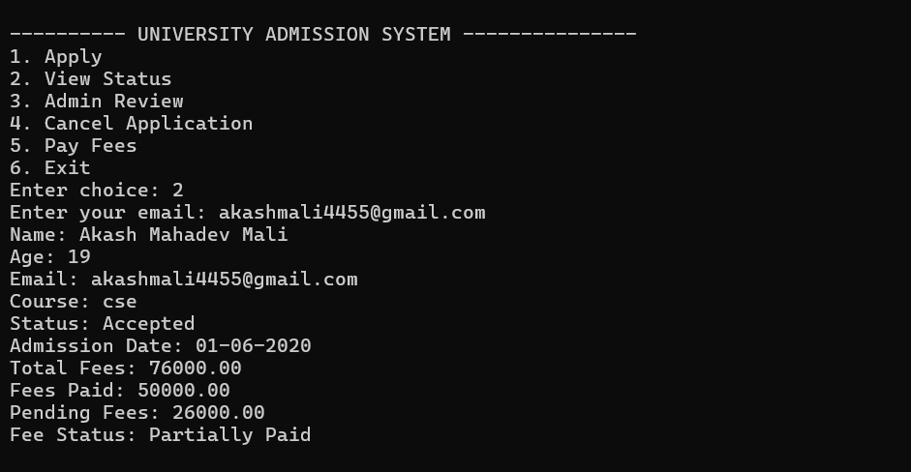

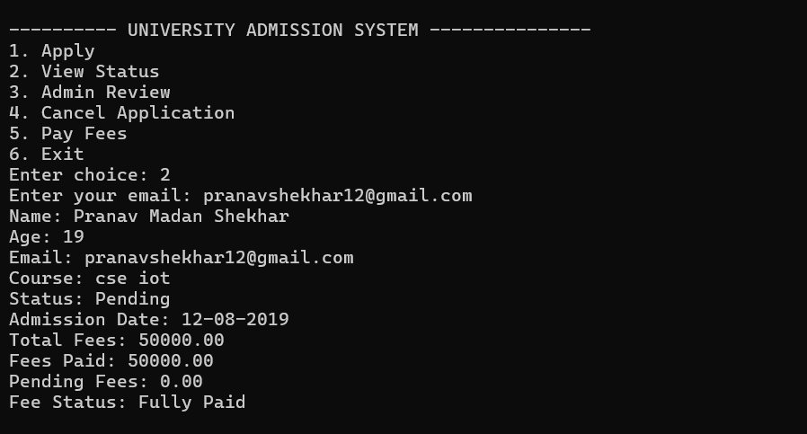

Pay fees:
The students complete their pending payments.
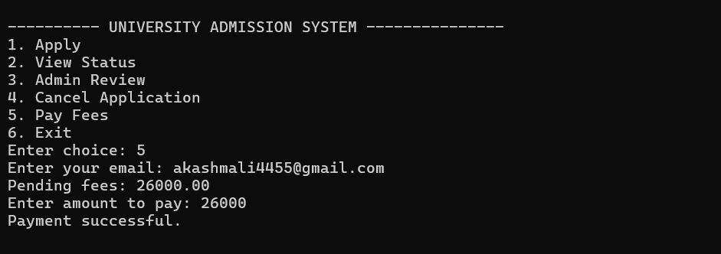

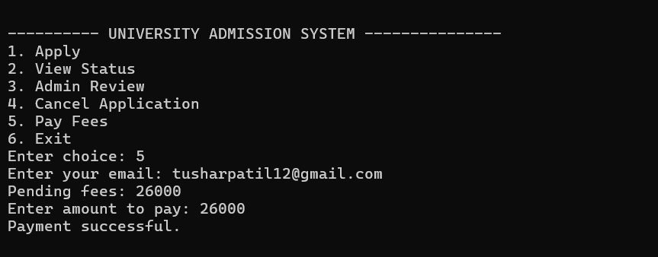

Cancel application:
If the applicants change their mind and wish to cancel their application so that they can go to other stream they can do so.
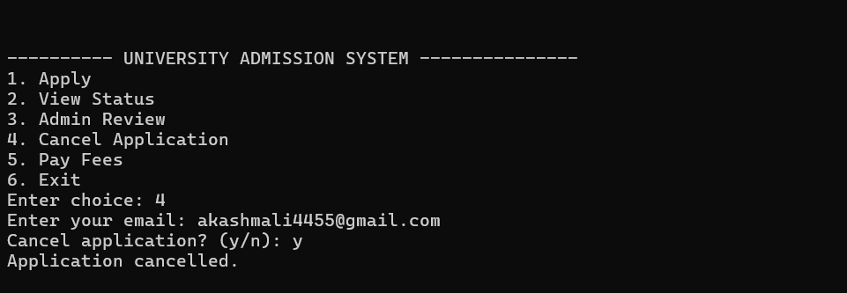

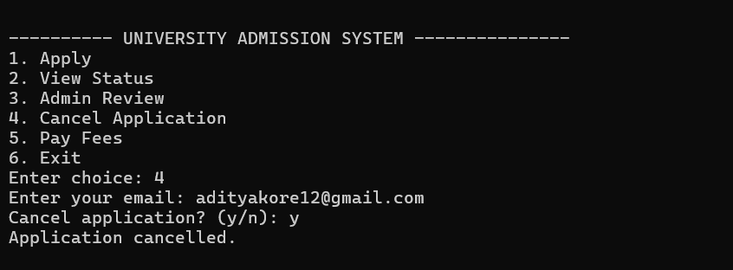

- Conclusion

The University Admission Management System has been successfully developed to streamline and automate the student admission process. The application enables administrators to manage applicant records, verify eligibility, handle fee transactions, and track admission status efficiently. It eliminates the need for manual paperwork and ensures that all student-related data is securely maintained for future reference.
Key features of the University Admission Management System include:
- Student Record Management: The system stores complete applicant information, including name, age, contact details, course applied for, and admission status, allowing staff to easily view, update, or search records.
- Admission Processing: Administrators can add new applications, verify candidate eligibility, and update admission decisions based on predefined criteria, ensuring a structured and transparent selection process.
- Fee Management: The system automatically calculates total fees, tracks paid and pending amounts, and updates payment status, ensuring accurate and transparent financial records.
- Data Storage and Retrieval: Using file handling operations, all student and fee details are saved permanently in external text files, ensuring that data remains available even after the program is closed.
- Editing and Searching: Users can edit existing records, update student information, or search for specific students by name or course, improving accessibility and administrative efficiency.
- Error Handling and Validation: The system prevents invalid inputs—such as incorrect ages, negative fees, or incomplete forms—ensuring accuracy and smooth operation.
This project effectively demonstrates the application of Object-Oriented Programming concepts such as encapsulation, abstraction, and modular design. File handling ensures persistent data storage, while the menu-driven interface provides a simple and user-friendly way to manage university admissions.

In conclusion, the University Admission Management System not only enhances operational efficiency and accuracy but also provides a scalable foundation for future expansion, such as integrating database connectivity or graphical interfaces. It showcases how fundamental C++ programming principles can be applied to build reliable, real-world solutions in the education domain.

9. Future Scope
While the University Admission Management System provides a strong foundation for automating the admission process, several future enhancements can be implemented to make the system more powerful, efficient, and user-friendly:
- Graphical User Interface (GUI):
  - Transitioning from a command-line interface to a graphical user interface (GUI) would make the system more interactive and accessible to users with minimal technical background.
  - A GUI-based system could include forms, buttons, and visual dashboards to make admission processing and data management faster and more intuitive.
- Online Admission Portal:
  - Developing a web or mobile-based version of the system would allow students to fill admission forms, upload documents, and track their admission status online.
  - Integration with automated email or SMS notifications for application confirmation, interview scheduling, and admission updates would enhance the communication process between the institution and applicants.
- Automated Fee Payment System:
  - Introducing online payment integration through debit/credit cards, UPI, or net banking could streamline the fee payment process and reduce manual work.
  - The system could also generate digital receipts and invoices, which can be automatically sent to students via email in PDF format.
- Enhanced Data Management and Analytics:
  - Future versions can include a reporting and analytics module to generate detailed reports on admission trends, course-wise enrollments, and fee collection summaries.
  - Data visualization tools like charts and graphs can help administrative staff make data-driven decisions for future academic planning.
- Cloud-Based Storage and Multi-Device Access:
  - Implementing cloud storage will ensure that all admission and student data is securely stored and backed up.
  - This would also allow authorized staff to access and update records from multiple devices and locations, improving operational flexibility.
- Document Verification and Record Tracking:
  - Integration of document upload and digital verification features can automate the validation of essential student documents like mark sheets, certificates, and ID proofs.
  - The system could maintain a digital trail of verified and pending applications for better transparency and auditability.
- Student Communication and Support System:
  - Future updates can include a chatbot or helpdesk module to assist students with admission queries in real-time.
  - Feedback and satisfaction surveys can be integrated to evaluate and improve the admission experience.
- Integration with University ERP or Database Systems:
  - The system can be expanded to work seamlessly with existing university management software for attendance, academic performance tracking, and result processing.
  - This will help create a unified and efficient digital ecosystem within the institution.

10. References
1. Books
• E. Balagurusamy. (2011). C++ Programming. McGraw-Hill Education.
• Bjarne Stroustrup. (2013). The C++ Programming Language (4th ed.). Addison-Wesley.
2. Online Courses
• Abdul Bari. C++ Programming [Udemy Course].
Retrieved from: https://www.udemy.com/course/cplusplus-tutorial-for-beginners/
• My Code School. Object-Oriented Programming in C++ [YouTube Course].
Retrieved from: https://www.youtube.com/user/mycodeschool

3. Video Tutorials
• Code With Harry. C++ File Handling [YouTube Video]. https://www.youtube.com/watch?v=Z1Yd7upQsXY
• Programming Knowledge. C++ Classes and Objects [YouTube Video]. https://www.youtube.com/watch?v=Rub-JsjMhWY
4. Online Resources
• GeeksforGeeks. C++ Programming Language. Retrieved from: https://www.geeksforgeeks.org/c-plus-plus/
• W3Schools. C++ File Handling Tutorial. Retrieved from: https://www.w3schools.com/cpp/cpp_files.asp
• TutorialsPoint. C++ Object-Oriented Programming Concepts. Retrieved from: https://www.tutorialspoint.com/cplusplus/cpp_object_oriented.htm

